EX:No. 5 221501060

5/4/2025

**Develop a linear regression model for forecasting time series data**

**Aim:**

Write a program to implement linear regression model for forecasting time series data.

**Algorithm:**

1. **Load the Data**:
   * Read the CSV file containing the weather data.
   * Parse the date column as a datetime index.
2. **Clean the Data**:
   * Handle missing values by performing forward and backward filling.
   * Drop any remaining NaN values.
3. **Normalize the Data**:
   * Apply **Min-Max Scaling** to normalize each column's values between 0 and 1.
4. **Add Time-Based Features**:
   * Extract additional features from the datetime index: day, month and year
5. **Visualize the Data**:
   * Plot the time series for a specific column (e.g., temperature T) over time.
6. **Execute the Program**:
   * Sequentially call the functions to load, clean, normalize, add features, and visualize the data.

**Code:**

import pandas as pd

import numpy as np

import matplotlib.pyplot as plt

from sklearn.linear_model import LinearRegression

from sklearn.metrics import mean_squared_error, r2_score

from sklearn.model_selection import train_test_split

date_rng = pd.date_range(start='2024-01-01', end='2024-03-01', freq='H')

np.random.seed(42)

energy_usage = np.random.normal(loc=1.5, scale=0.5, size=len(date_rng)) + np.linspace(0, 3, len(date_rng))

df = pd.DataFrame({'timestamp': date_rng, 'energy_kWh': energy_usage})

df.set_index('timestamp', inplace=True)

daily_data = df.resample('D').mean()

daily_data = daily_data.reset_index()

daily_data['day_index'] = np.arange(len(daily_data)) # use as input for regression

X = daily_data[['day_index']]

y = daily_data['energy_kWh']

X_train, X_test, y_train, y_test = train_test_split(X, y, shuffle=False, test_size=0.2)

lr = LinearRegression()

lr.fit(X_train, y_train)

y_pred = lr.predict(X_test)

print("Linear Regression Forecasting Results:")

print("R^2 Score:", r2_score(y_test, y_pred))

print("RMSE:", np.sqrt(mean_squared_error(y_test, y_pred)))

plt.figure(figsize=(12, 5))

plt.plot(y_test.values, label='Actual Energy', marker='o')

plt.plot(y_pred, label='Predicted Energy', marker='x')

plt.title('Actual vs Predicted Energy Consumption (Test Set)')

plt.xlabel('Time (Days)')

plt.ylabel('Energy (kWh)')

plt.legend()

plt.grid(True)

plt.tight_layout()

plt.show()

future_days = 10

future_indices = np.arange(len(daily_data), len(daily_data) + future_days).reshape(-1, 1)

future_forecast = lr.predict(future_indices)

plt.figure(figsize=(12, 5))

plt.plot(daily_data['day_index'], y, label='Historical Energy Usage')

plt.plot(future_indices.flatten(), future_forecast, label='Forecast (Next 10 Days)', marker='o', color='red')

plt.title('Energy Consumption Forecast (Linear Regression)')

plt.xlabel('Day Index')

plt.ylabel('Energy (kWh)')

plt.legend()

plt.grid(True)

plt.tight_layout()

plt.show()

**Output:**

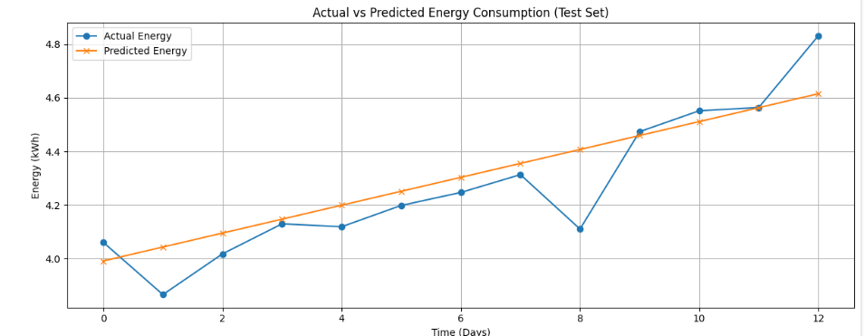

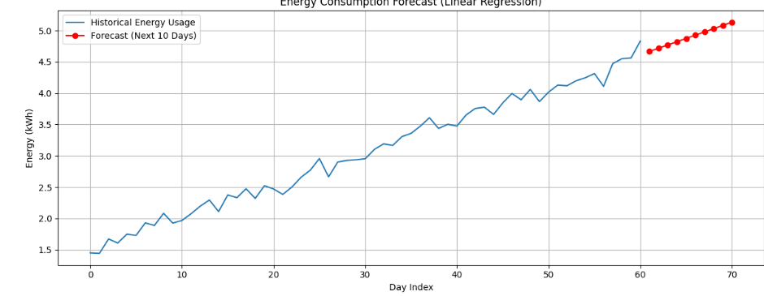

**Result:**

Thus, the program using the time series data implementation has been done successfully.